Name: Amogh Nagarkar

Super Set ID: 6403503

**Objectives**

* Explain git ignore
* Explain how to ignore unwanted files using git ignore

In this hands-on lab, you will learn how to:

* Implement git ignore command to ignore unwanted files and folders

**Solution:**

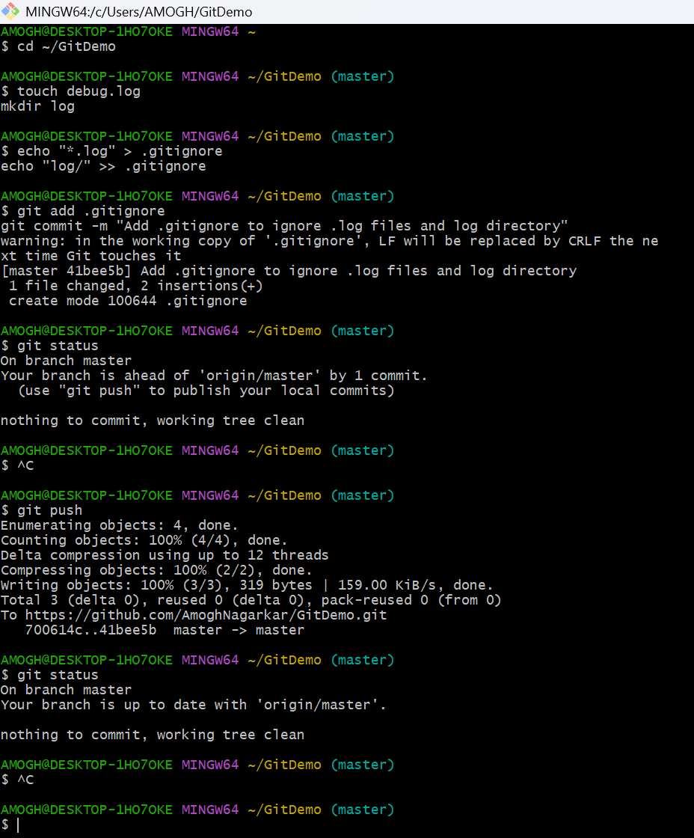

* Created a .log file and a log folder in the working directory.
* Added patterns in .gitignore to ignore all .log files and the log directory.
* Committed .gitignore and pushed changes to the remote repository.
* Verified using git status that the working tree is clean and .log files / log folder remain ignored by Git.